BIG DATA PROJECT · MIDTERM · PHASE 2
Scalable Order Data
Processing and Analytics Platform
PySpark · MongoDB · FastAPI · Query Optimization · Scheduled Jobs

Student | Qusai Saad Saad Qaria
Engineering Supervisor | Eng. Omar Abu Sand
Course | Big Data - Practical
Project Status | Final execution and testing completed
This report documents a complete order-data pipeline from CSV ingestion to analytical reporting, indexed queries, materialized views, and scheduled execution.
Verification note: the numerical measurements and configuration values in this draft reproduce the execution evidence supplied for the Phase 2 project and should be checked against the student's own run before submission.

01 · PROJECT CONTEXT

Problem Context and Implementation Scope
The project implements an end-to-end data-processing pipeline for a large order dataset. Its purpose is to ingest raw CSV data, clean and normalize inconsistent values, isolate records that cannot be repaired safely, persist the resulting data in MongoDB, and expose operational and analytical functions through a REST API.
Phase 2 extends the processing pipeline beyond ingestion. It introduces FastAPI service endpoints, MongoDB indexes, query-performance analysis with Explain, aggregation reports, materialized views, incremental refresh logic, and scheduled jobs. The resulting architecture therefore combines data engineering, NoSQL storage, API delivery, analytics, and automation in one workflow.

Implementation objectives
- Process a large source file with an execution strategy selected according to file size.
- Preserve raw records while applying traceable data-quality corrections.
- Quarantine critical errors instead of inventing missing business identifiers.
- Provide testable service endpoints for ingestion, indexes, queries, aggregations, materialized views, and jobs.
- Measure the practical effect of indexing rather than assuming that an index improves performance.

Delivered capability map
Capability | Implementation
Large-file processing | PySpark
Data quality | Cleaning, correction, classification
Persistence | MongoDB
Service layer | FastAPI + Uvicorn
Performance | Indexes + Explain
Analytics | Aggregation reports
Precomputed analytics | Materialized Views
Incremental updates | Watermark-based refresh
Automation | Scheduled Jobs

02 · SYSTEM DESIGN

System Architecture and Data Flow
The architecture separates ingestion, processing, validation, storage, delivery, and analytical workloads. The routing decision at the beginning of the pipeline allows smaller files to be handled with standard Python batch processing, while larger inputs are directed to PySpark.
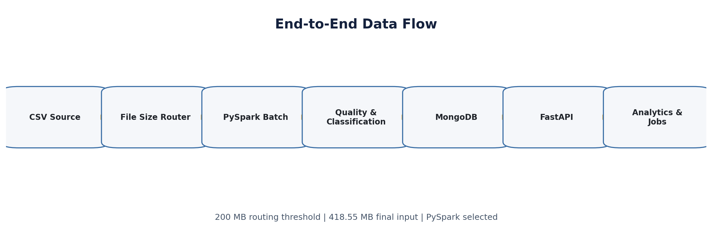
Figure 1. Original architecture diagram for the Phase 2 data flow.

Processing-engine selection
200 MB  small-file threshold | 418.55 MB  final input size | PySpark  selected engine
The final input file is approximately 418.55 MB, which exceeds the 200 MB threshold. For this run, PySpark is therefore selected instead of the lightweight Python csv.DictReader batch path.

Execution environment
Parameter | Recorded value
Spark version | 4.2.0
Input partitions | 300
Processing model | Parallel PySpark batch execution

03 · PIPELINE EXECUTION

Final Run and Core Processing Results
1,000,000  raw records | 993,020  corrected | 6,980  quarantined | 949.48  records / second
The final run loaded all 1,000,000 source records. Of these, 993,020 records were corrected according to the implemented quality rules, while 6,980 records were moved to quarantine because of a critical data issue. No records were classified as Valid in this specific execution.

Execution metrics
Metric | Value | Interpretation
Raw loaded | 1,000,000 | All input records were ingested.
Corrected | 993,020 | Records repaired by deterministic quality rules.
Quarantine | 6,980 | Records containing a critical unresolved error.
Valid | 0 | Final result for this execution.
Execution time | 1053.21 seconds | Total recorded runtime.
Throughput | 949.48 records/second | Average processing rate.
reports/results.json
Execution time: 1053.21 seconds
Throughput: 949.48 records/second

04 · DATA QUALITY

Cleaning, Normalization, and Classification Strategy
Data correction is controlled by explicit quality rules. Each rule targets a known inconsistency and converts it into a standardized representation. This approach keeps the pipeline deterministic and avoids arbitrary edits to the source data.
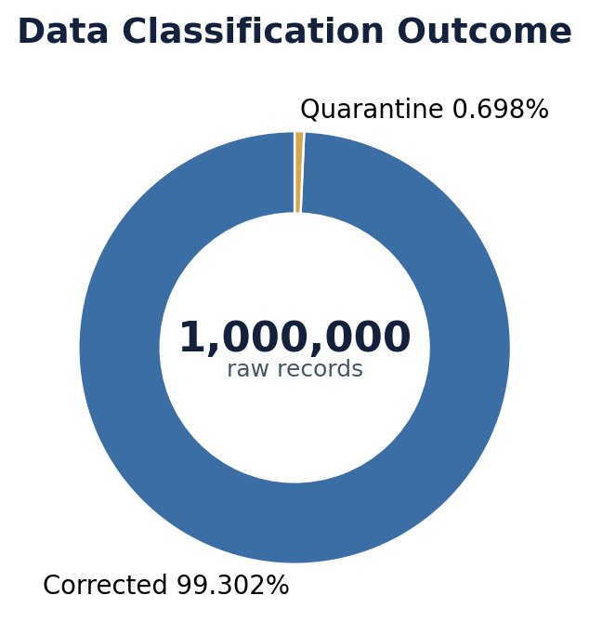
Figure 2. Classification outcome for the 1,000,000-record run.

04 · DATA QUALITY · CONTINUED

Quality Rules and Quarantine Policy

Implemented quality rules
No. | Quality area | Processing action
1 | Arabic digits | Convert Arabic numeral forms into a consistent numeric representation.
2 | Currencies | Normalize currency representations.
3 | Thousands separators | Clean separators and spacing inside numeric values.
4 | Prices written as words | Handle known textual expressions representing prices.
5 | Phone numbers | Normalize telephone-number format.
6 | Email addresses | Repair selected issues such as repeated symbols.
7 | Dates | Standardize date format.
8 | Whitespace | Remove redundant spacing and normalize whitespace.
9 | Descriptive values | Normalize Status, Payment, Delivery, and their known synonyms.
10 | amount_total | Recalculate from valid line items and delivery fees.

Quarantine policy
The recorded quarantine reason is MISSING_ORDER_ID, affecting 6,980 records. Because the missing value is a business identifier, the pipeline does not fabricate an order identifier. The record is isolated for review instead of being silently repaired with an unverified value.

05 · STORAGE LAYER

MongoDB Collections and Idempotent Persistence
MongoDB is used to separate raw history, processed business records, and unresolved records. The collection design preserves traceability while supporting safe re-execution of the pipeline.

Primary collections
Collection | Role
raw_orders | Preserves raw data and execution-attempt history.
validated_orders | Stores processed business records using order_id as the business key.
quarantine_orders | Stores records containing critical errors that require review.

Idempotency mechanism
order_id  business key | Unique  index constraint | Upsert  write strategy
Idempotency ensures that reprocessing the same source data does not create duplicate business records in validated_orders. A unique index on order_id protects the business key, while upsert is used for persistence. raw_orders intentionally retains execution history and can therefore contain more than one ingestion attempt for the same source.

06 · SERVICE LAYER

FastAPI Service Interface and Endpoint Design
The Phase 2 service layer is implemented as a REST API using FastAPI and Uvicorn. It exposes the major operational capabilities of the system and provides interactive Swagger documentation for testing.
uvicorn src.phase2.api:app --host 127.0.0.1 --port 8000
Uvicorn running on http://127.0.0.1:8000
Application startup complete.

API endpoint inventory
Group | Endpoint | Purpose
System | GET /health | Check service availability.
Pipeline | POST /ingest | Run the ingestion process.
Indexes | POST /indexes | Create indexes.
Indexes | GET /indexes/status | Inspect index state.
Queries | GET /queries | List available queries.
Queries | GET /queries/{name} | Execute a named query.
Queries | GET /queries/{name}/explain | Inspect query execution behavior.
Aggregations | GET /aggregations | List aggregation reports.
Aggregations | GET /aggregations/{name} | Execute a named aggregation.
Materialized Views | POST /refresh-mv | Refresh materialized views.
Materialized Views | GET /materialized-views | List materialized views.
Materialized Views | GET /materialized-views/{name} | Read a materialized view.
Jobs | GET /jobs | List scheduled jobs.
Jobs | POST /jobs/{name}/run | Run a scheduled job manually.
Swagger documentation is available at http://127.0.0.1:8000/docs when the service is running.

07 · QUERY OPTIMIZATION

Queries, Index Design, and Explain-Based Measurement
The query layer includes common access patterns for city, status, date, customer, and combined city/status filtering. Indexes are aligned with these patterns so that the database can reduce document scanning and improve execution time.

Named queries
- orders_by_city
- orders_by_status
- orders_by_date
- customer_orders
- city_status_orders

Created indexes
Index | Purpose
phase2_city | Improve city filtering.
phase2_status | Improve status filtering.
phase2_order_date | Improve date-based access.
phase2_customer_id | Improve customer queries.
phase2_city_status | Improve compound city/status queries.
phase2_total_amount | Improve queries on order value.
order_id - Unique | Prevent duplicate business records.

07 · QUERY OPTIMIZATION · CONTINUED

Index Performance and Explain Evidence
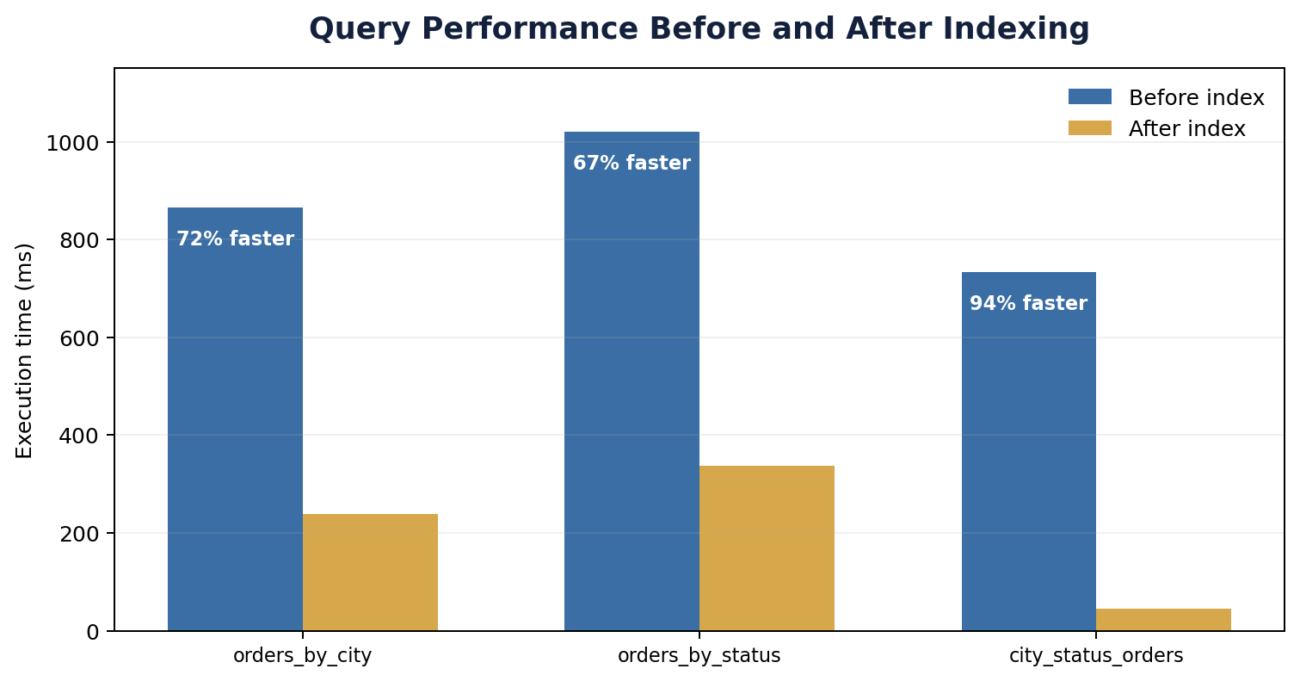
Figure 3. Recorded query latency before and after indexing.

Explain evidence
The recorded improvements were approximately 72% for orders_by_city, 67% for orders_by_status, and 94% for city_status_orders. For the city query, scanning decreased from approximately 986,060 documents to the matching set, with totalDocsExamined = 98,891 and totalKeysExamined = 98,891.

08 · ANALYTICAL LAYER

Aggregation Reports and Business-Level Summaries
The analytical layer provides five independent aggregation reports. These reports transform operational order records into reusable summaries for location, status, date, and customer analysis.

Available aggregation reports
- sales_by_city
- sales_by_status
- sales_by_date
- top_customers
- top_cities

Example city-level output
City | Order count
Aden | 99,083
Sana'a | 98,891
Al Mukalla | 98,882
Al Hudaydah | 98,031
The aggregation layer calculates order counts together with sales totals and average order value, allowing MongoDB to support both operational retrieval and analytical reporting.

09 · PRECOMPUTED ANALYTICS AND AUTOMATION

Materialized Views, Incremental Refresh, and Scheduled Jobs
Materialized views store selected analytical results so that repeated API requests do not need to recompute the same aggregation pipelines from scratch. The project also implements incremental refresh behavior and scheduled execution.
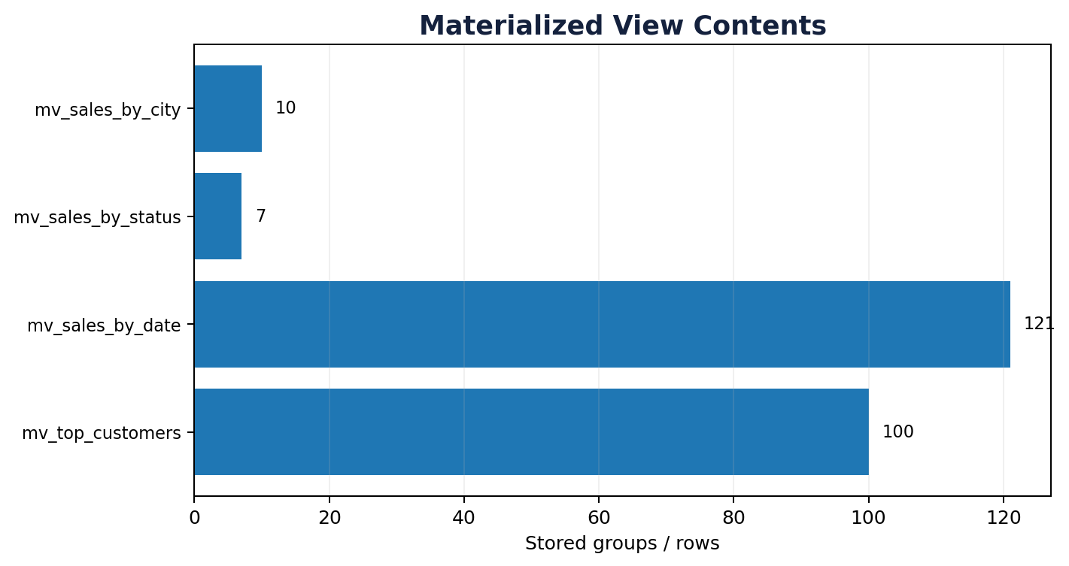
Figure 4. Recorded contents of the materialized views.

Incremental refresh result
refresh_materialized_views
status: success
mode: incremental
changed_records: 0
event_count: 0
city_groups: 0
status_groups: 0
This result indicates that the refresh operation completed successfully, but no new or changed records required group recomputation at the time of testing. A new watermark was recorded for the refresh process.

Scheduled jobs
Job | Function | Result
refresh_materialized_views | Refresh materialized views. | success
periodic_aggregation_report | Run aggregation reports periodically. | success
periodic_aggregation_report
sales_by_city: 10
sales_by_status: 7

10 · REPRODUCIBILITY

Configuration, Result Files, and Re-Execution Procedure
Project configuration is separated from source code through environment variables. This reduces code changes when moving the project between machines and makes runtime parameters explicit.

Data and storage variables
DATA_FILE
MONGO_URI
DB_NAME
RAW_COLLECTION
VALID_COLLECTION
QUAR_COLLECTION

Processing variables
SMALL_FILE_THRESHOLD_MB
BATCH_SIZE
SPARK_MASTER
SPARK_DRIVER_MEMORY
SPARK_MAX_PARTITION_BYTES

Phase 2 variables
DELTA_FILE
VERSION_FIELD
RECORD_HASH_FIELD
PHASE2_JOB_INTERVAL_SECONDS
PHASE2_REPORT_INTERVAL_SECONDS

Recorded result files
File | Purpose
reports/results.json | Pipeline execution results.
reports/phase2_explain.json | Before/after query-performance evidence.
reports/phase2_jobs.jsonl | Scheduled-job execution results.

Execution sequence
pip install -r requirements.txt
# Copy env.example to .env and update paths/settings
# Start MongoDB
python main.py
uvicorn src.phase2.api:app --host 127.0.0.1 --port 8000
# Open http://127.0.0.1:8000/docs

11 · PERFORMANCE ASSESSMENT

Engineering Evaluation of the Final System
The final execution demonstrates that the pipeline can process 1,000,000 records in a single run with an average throughput of 949.48 records per second. The classification stage separates corrected data from records that require manual or upstream remediation, which protects the validated dataset from a known critical identifier error.
Index measurements provide concrete evidence of query improvement. orders_by_city decreased from 866 ms to 239 ms, orders_by_status from 1021 ms to 337 ms, and city_status_orders from 733 ms to 45 ms. The strongest recorded improvement is therefore the compound city/status query at approximately 94%.

Phase coverage
Data engineering layer | API and analytical layer
CSV ingestion and engine routing | FastAPI REST service
Quality rules and deterministic correction | Queries and indexes
Quarantine of critical records | Explain-based performance analysis
MongoDB + idempotent persistence | Aggregation reports + materialized views
Execution metrics and reporting | Incremental refresh + scheduled jobs

Key engineering strengths
- Traceability: raw records and processing outputs are separated.
- Safety of correction: missing business identifiers are quarantined rather than guessed.
- Repeatability: idempotent writes protect validated business records from duplication.
- Measured optimization: index impact is demonstrated with Explain and timing evidence.
- Operational completeness: API, reports, materialized views, incremental refresh, and jobs are all represented in the final system.

12 · CONCLUSION

Final Conclusion
Phase 2 results in an integrated big-data application rather than a standalone cleaning script. The implementation begins with file-size-aware ingestion, selects PySpark for the 418.55 MB input, applies deterministic quality rules, and persists data in MongoDB with explicit separation between raw, validated, and quarantined records.
The second layer turns the stored data into an operational service. FastAPI exposes ingestion, index, query, aggregation, materialized-view, and job functions. Query performance is measured with MongoDB Explain, while aggregation reports and materialized views provide analytical summaries that can be reused without repeatedly rebuilding the same computations.
The recorded test evidence shows successful pipeline execution, working API startup, created indexes, measurable query acceleration, available aggregation reports, populated materialized views, successful incremental-refresh execution, and successful scheduled jobs. Taken together, the project demonstrates practical integration of Big Data Processing, Data Quality, NoSQL Storage, REST APIs, Query Optimization, Analytics, Incremental Processing, and Automation.
END OF REPORT
Prepared by Qusai Saad Saad Qaria · Supervised by Eng. Omar Abu Sand

